**Project Design Phase-II**

**Data Flow Diagram & User Stories**

|  |  |
| --- | --- |
| Date | 12 October 2022 |
| Team ID | PNT2022TMID09895 |
| Project Name | Project - Car Resale Value Prediction |
| Maximum Marks | 4 Marks |

**Data Flow Diagrams:**

A Data Flow Diagram (DFD) is a traditional visual representation of the information flows within a system. A neat and clear DFD can depict the right amount of the system requirement graphically. It shows how data enters and leaves the system, what changes the information, and where data is stored.

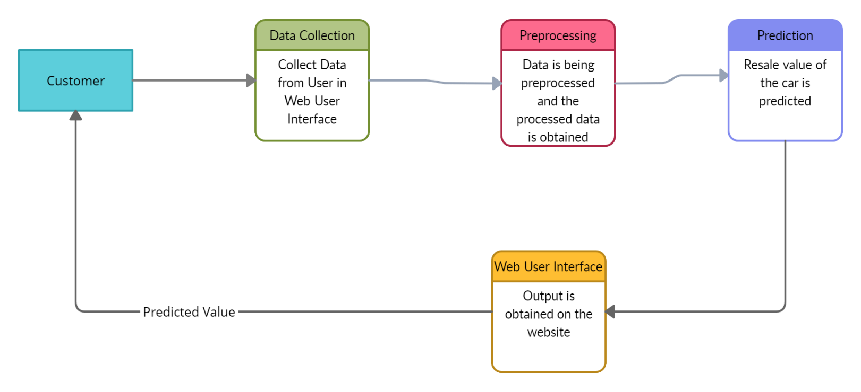

**User Stories**

|  |  |  |  |  |  |  |
| --- | --- | --- | --- | --- | --- | --- |
| **User Type** | **Functional**  **Requirement**  **(Epic)** | **User**  **Story**  **Number** | **User Story/Task** | **Acceptance**  **Criteria** | **Priority** | **Release** |
| Customer  (Desktop User) | Data Entry | USN - 1 | User can enter the car details in the website. | Enters the car details | Medium | Sprint-1 |
| Customer  (Desktop User) | Obtain Output | USN - 2 | User will receive car resale value in the website. | Receives the car resale value | High | Sprint-1 |